
FACULTY OF TECHNOLOGY AND ENGINEERING
DEVANG PATEL INSTITUTE OF ADVANCE TECHNOLOGY
AND RESEARCH

DEPARTMENT OF COMPUTER ENGINEERING

A.Y 2026 – 27 Semester – 3

LAB MANUAL

CSUC201 Fundamentals of Data Structures and Algorithms

Practical 1: Array Operations: Traversal, Rotation, and Frequency Analysis

Practical Aim : To implement hash tables using different collision handling strategies and develop the ability to
reason about why collisions occur, how different strategies resolve them, and what trade-offs
each approach involves.

Problem 1
A small parking lot has exactly 10 numbered slots (0 to 9). When a vehicle arrives, its
registration number is used to assign it a slot by taking the last digit of the number. If that slot is
already taken, the vehicle moves to the next available slot in order, wrapping around if
necessary. Given a sequence of vehicle registrations, assign each to a slot using this rule and
display the final state of all ten slots.
Describe what your solution does when it encounters an already occupied slot. What happens
when the parking lot is nearly full and many vehicles keep landing on the same slot? Can you
think of a situation where your solution might loop indefinitely?
Problem 2
A library uses a system with 10 shelves numbered 0 to 9. Each book's code is used to decide
which shelf it belongs to by taking the code modulo 10. Unlike the parking lot, each shelf can
hold multiple books stacked together — when two books map to the same shelf, they are simply
added to that shelf's stack. Given a sequence of book codes, place each on the correct shelf
and display the final contents of all shelves.
Describe how your solution handles two books that map to the same shelf. What happens to
search time on a shelf as more and more books pile onto it? Can you think of what would cause
all books to end up on the same shelf?
Problem 3
A university assigns student IDs to storage slots using a two-step rule. The first rule determines
the initial slot. If that slot is taken, instead of simply moving one slot forward, a second rule
based on the ID itself determines how many slots to jump. This means different IDs that collide
will probe different sequences of slots, spreading them more evenly. Given a sequence of
student IDs, assign each to a slot using both rules and display the final state of the table.
Describe how your solution decides how many slots to jump when a collision occurs. What is
the risk if the jump size happens to be a factor of the table size? How does this strategy differ
from Problem 10.1 in how it spreads collisions?

For Code: https://github.com/DivyaParadiya/FDSA_A_SHP

Output:
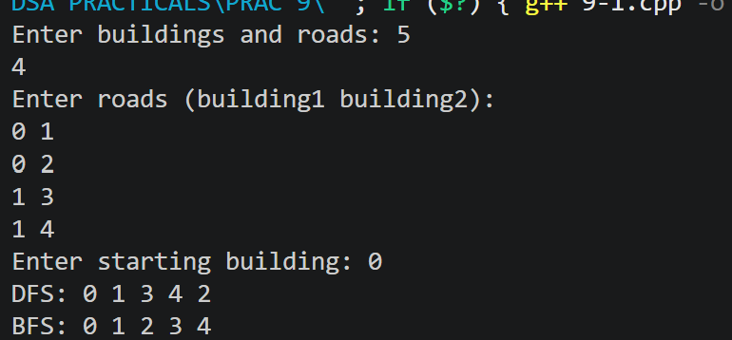
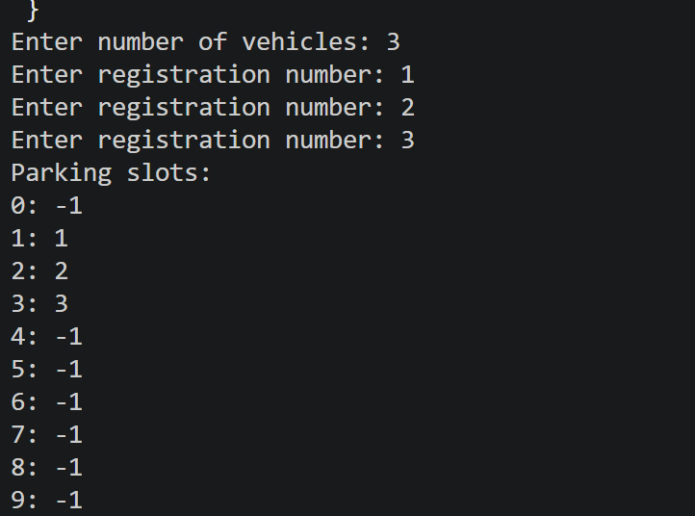
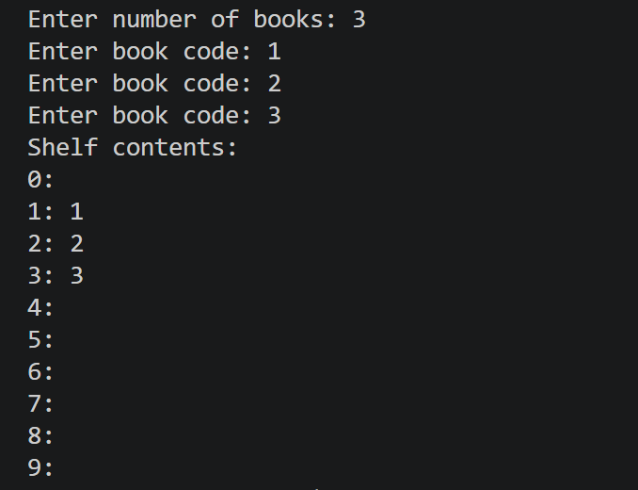

Outcome/Conclusion: Students will be able to implement hash tables using three different collision handling strategies,
explain why collisions occur and how each strategy resolves them differently, and reason about
the conditions under which each strategy performs well or breaks down.

Key Questions / Analysis / Interpretation to be Evaluated During/After Implementation

1.
Question: If five consecutive vehicle registrations all end in the same digit, trace where each one gets placed in the parking lot. Now explain why this clustering effect is a structural weakness of this collision strategy — not just for this input, but in general.
Answer:
If five vehicle registrations end in the same digit, they initially map to the same slot. The first vehicle occupies that slot, and the remaining four are placed in the next available slots using linear probing. For example, if all registrations end in 3, they occupy slots 3, 4, 5, 6, and 7. This creates clustering because consecutive occupied slots form a group. Future vehicles that map to this group may have to check several slots before finding an empty one, increasing insertion time.

2. [Problem 2]
Question: Suppose all book codes in Problem 2 are multiples of 10. Without tracing through the code, predict what the final shelf layout would look like and explain why. What does this tell you about the relationship between the hash function and the input data?
Answer:
All book codes would be stored on shelf 0 because every multiple of 10 has a remainder of 0 when divided by 10. The other nine shelves would remain empty. This shows that the performance of a hash table depends on how well the hash function distributes the input data across the available shelves. Poor distribution can cause one shelf to become overcrowded.

3. [Problem 3]
Question: In Problem 3, what would happen if the second rule always produced a jump size of zero? Trace through the consequence and explain how this failure is related to the choice of the second hash function rather than the data itself.
Answer:
If the second hash function always produced a jump size of zero, the position would never change after a collision. The program would repeatedly check the same occupied slot and fail to find another empty slot. This could cause an infinite loop if there were no limit on attempts. The problem lies in the design of the second hash function because a zero jump cannot explore other slots, regardless of the input data. A proper second hash function must produce a nonzero jump that allows the probing sequence to reach the available slots.

